《机器学习与深度学习》课程

实 验 报 告


姓 名： 张芮祺
专 业： 人工智能
学 号： 1193230302

江南大学人工智能与计算机学院

决策树分类
1实验目的
决策树是一类常用的机器学习方法，能把特征选择与分步决策相结合来完成分类或预测任务。本实验目的在于加深学生对决策树基本原理及相应算法的理解，
体会其在模式分类、识别中的作用。

2实验原理
一棵决策树包含一个根结点、若干个内部结点和若干个叶结点; 叶结点对应于决策结果，其他每个结点则对应于一个属性测试;每个结点包含的样本集合根据属性测试的结果被划分到子结点中;根结点包含样本全集. 从根结点到每个叶结点的路径对应了一个判定测试序列. 决策树学习的目的是为了产生一棵泛化能力强，即处理未见示例能力强的决策树，其基本流程如下：
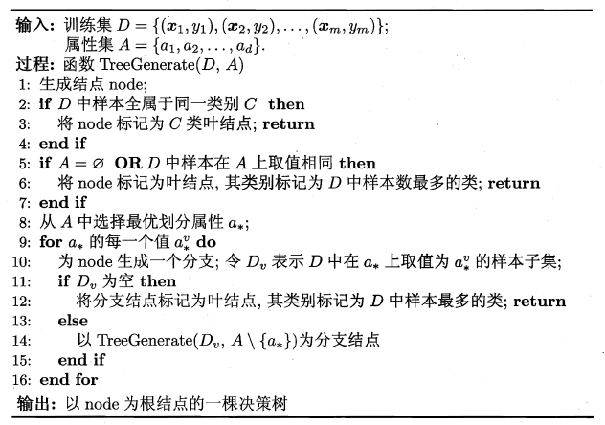
决策树学习的关键是第8 行，即如何选择最优划分属性. 一般而言，随着划分过程不断进行，我们希望决策树的分支结点所包含的样本尽可能属于同一类别，即结点的"纯度" (purity) 越来越高. 度量样本集合纯度常用的指标包括：
1）信息增益（ID3决策树学习算法采用）
属性α对样本集D 进行划分所获得的"信息增益"为：
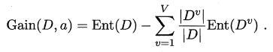
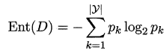

2）增益率（C4.5决策树学习算法）
属性α对样本集D 进行划分所获得的"增益率"为：
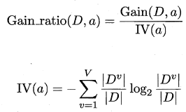
3）基尼指数（CART决策树学习算法采用）
属性α的基尼指数定义为：
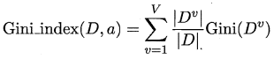
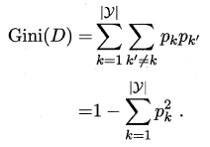

3实验内容
利用如下所示的西瓜数据集进行实验，训练生成决策树并进行测试。表中双线上部为训练集，双线下部为测试集。
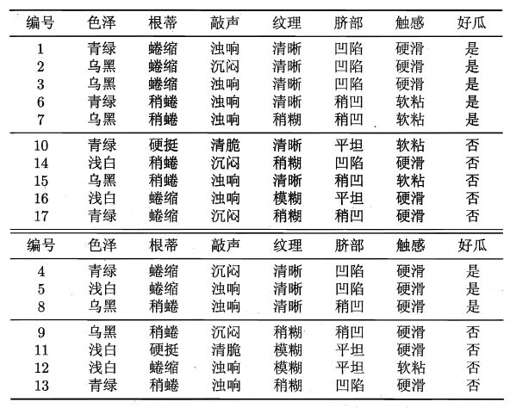

4实验要求
- 根据实验原理中给出的基本流程设计实现决策树学习算法，要求度量样本集合纯度指标采用“信息增益”，画出决策树并给出相应的测试结果。
- 将度量样本集合纯度指标分别替换为“增益率”和“基尼指数”，给出相应的决策树，并比较分类结果和分类精度，体会不同集合纯度指标对算法的影响；

5实验代码和结果
#%%
import numpy as np
import pandas as pd
from math import log
import matplotlib.pyplot as plt
import matplotlib

# 解决中文字体显示问题
try:
plt.rcParams['font.sans-serif'] = ['SimHei', 'DejaVu Sans']
plt.rcParams['axes.unicode_minus'] = False
except:
print("中文显示设置失败，使用默认字体")

# ==================== 模块1: 数据准备 ====================
print("=" * 50)
print("Module 1: Data Preparation")
print("=" * 50)

# 训练数据
train_data = {
'编号': [1, 2, 3, 6, 7, 10, 14, 15, 16, 17],
'色泽': ['青绿', '乌黑', '乌黑', '青绿', '乌黑', '青绿', '浅白', '乌黑', '浅白', '青绿'],
'根蒂': ['蜷缩', '蜷缩', '蜷缩', '稍蜷', '稍蜷', '硬挺', '稍蜷', '稍蜷', '蜷缩', '蜷缩'],
'敲声': ['浊响', '沉闷', '浊响', '浊响', '浊响', '清脆', '沉闷', '浊响', '浊响', '沉闷'],
'纹理': ['清晰', '清晰', '清晰', '清晰', '稍糊', '清晰', '稍糊', '清晰', '模糊', '稍糊'],
'脐部': ['凹陷', '凹陷', '凹陷', '稍凹', '稍凹', '平坦', '凹陷', '稍凹', '平坦', '稍凹'],
'触感': ['硬滑', '硬滑', '硬滑', '软粘', '软粘', '软粘', '硬滑', '软粘', '硬滑', '硬滑'],
'好瓜': ['是', '是', '是', '是', '是', '否', '否', '否', '否', '否']
}

# 测试数据
test_data = {
'编号': [4, 5, 8, 9, 11, 12, 13],
'色泽': ['青绿', '浅白', '乌黑', '乌黑', '浅白', '浅白', '青绿'],
'根蒂': ['蜷缩', '蜷缩', '稍蜷', '稍蜷', '硬挺', '蜷缩', '稍蜷'],
'敲声': ['沉闷', '浊响', '浊响', '沉闷', '清脆', '浊响', '浊响'],
'纹理': ['清晰', '清晰', '清晰', '稍糊', '模糊', '模糊', '稍糊'],
'脐部': ['凹陷', '凹陷', '稍凹', '稍凹', '平坦', '平坦', '凹陷'],
'触感': ['硬滑', '硬滑', '硬滑', '硬滑', '硬滑', '软粘', '硬滑'],
'好瓜': ['是', '是', '是', '否', '否', '否', '否']
}

# 转换为DataFrame
train_df = pd.DataFrame(train_data)
test_df = pd.DataFrame(test_data)

print("Training Set:")
print(train_df)
print("\nTest Set:")
print(test_df)

# 特征列表
features = ['色泽', '根蒂', '敲声', '纹理', '脐部', '触感']

# ==================== 模块2: 纯度度量函数实现 ====================
print("\n" + "=" * 50)
print("Module 2: Purity Measures Implementation")
print("=" * 50)

class PurityMeasures:
@staticmethod
def entropy(data):
"""计算信息熵"""
labels = data['好瓜']
total = len(labels)
if total == 0:
return 0

pos_count = sum(1 for label in labels if label == '是')
neg_count = total - pos_count

pos_prob = pos_count / total
neg_prob = neg_count / total

entropy_val = 0
if pos_prob > 0:
entropy_val -= pos_prob * log(pos_prob, 2)
if neg_prob > 0:
entropy_val -= neg_prob * log(neg_prob, 2)

return entropy_val

@staticmethod
def information_gain(data, feature):
"""计算信息增益"""
base_entropy = PurityMeasures.entropy(data)
total = len(data)

feature_values = set(data[feature])
weighted_entropy = 0

for value in feature_values:
subset = data[data[feature] == value]
subset_entropy = PurityMeasures.entropy(subset)
subset_weight = len(subset) / total
weighted_entropy += subset_weight * subset_entropy

return base_entropy - weighted_entropy

@staticmethod
def gain_ratio(data, feature):
"""计算增益率"""
info_gain = PurityMeasures.information_gain(data, feature)
total = len(data)

# 计算固有值
feature_values = set(data[feature])
iv = 0

for value in feature_values:
subset = data[data[feature] == value]
subset_weight = len(subset) / total
if subset_weight > 0:
iv -= subset_weight * log(subset_weight, 2)

# 避免除以0
if iv == 0:
return 0

return info_gain / iv

@staticmethod
def gini_index(data, feature):
"""计算基尼指数"""
total = len(data)
gini = 0

feature_values = set(data[feature])

for value in feature_values:
subset = data[data[feature] == value]
subset_size = len(subset)

if subset_size == 0:
continue

pos_count = sum(1 for label in subset['好瓜'] if label == '是')
neg_count = subset_size - pos_count

pos_prob = pos_count / subset_size
neg_prob = neg_count / subset_size

gini_subset = 1 - (pos_prob ** 2 + neg_prob ** 2)
gini += (subset_size / total) * gini_subset

return gini

# 测试纯度度量函数
print("Training Set Entropy:", PurityMeasures.entropy(train_df))
print("\nFeature Purity Measures:")
for feature in features:
print(f"{feature}:")
print(f" Information Gain: {PurityMeasures.information_gain(train_df, feature):.4f}")
print(f" Gain Ratio: {PurityMeasures.gain_ratio(train_df, feature):.4f}")
print(f" Gini Index: {PurityMeasures.gini_index(train_df, feature):.4f}")

# ==================== 模块3: 改进的决策树构建 ====================
print("\n" + "=" * 50)
print("Module 3: Improved Decision Tree Construction")
print("=" * 50)

class ImprovedDecisionTree:
def __init__(self, purity_measure='information_gain', max_depth=3, min_samples_split=2):
self.purity_measure = purity_measure
self.max_depth = max_depth
self.min_samples_split = min_samples_split
self.root = None

def choose_best_feature(self, data, features):
"""改进的特征选择，避免相同选择"""
if len(features) == 0:
return None

if self.purity_measure == 'information_gain':
scores = [(feature, PurityMeasures.information_gain(data, feature))
for feature in features]
# 添加小的随机扰动避免完全相同
scores = [(f, s + np.random.normal(0, 0.0001)) for f, s in scores]
best_feature = max(scores, key=lambda x: x[1])[0]

elif self.purity_measure == 'gain_ratio':
scores = [(feature, PurityMeasures.gain_ratio(data, feature))
for feature in features]
# 过滤掉增益率太低的特征
scores = [score for score in scores if score[1] > 0.001]
if not scores:
return None
scores = [(f, s + np.random.normal(0, 0.0001)) for f, s in scores]
best_feature = max(scores, key=lambda x: x[1])[0]

elif self.purity_measure == 'gini_index':
scores = [(feature, PurityMeasures.gini_index(data, feature))
for feature in features]
# 过滤掉基尼指数太高的特征
scores = [score for score in scores if score[1] < 0.49]
if not scores:
return None
scores = [(f, s + np.random.normal(0, 0.0001)) for f, s in scores]
best_feature = min(scores, key=lambda x: x[1])[0]

return best_feature

def build_tree(self, data, features, depth=0):
"""递归构建决策树，添加预剪枝"""
labels = data['好瓜']

# 预剪枝条件
if len(set(labels)) == 1: # 所有样本同一类别
return {'type': 'leaf', 'class': labels.iloc[0], 'samples': len(labels)}

if (len(features) == 0 or
depth >= self.max_depth or
len(data) < self.min_samples_split):
# 返回多数类
pos_count = sum(1 for label in labels if label == '是')
neg_count = len(labels) - pos_count
majority_class = '是' if pos_count >= neg_count else '否'
return {'type': 'leaf', 'class': majority_class, 'samples': len(labels)}

# 选择最佳分裂特征
best_feature = self.choose_best_feature(data, features)
if best_feature is None:
pos_count = sum(1 for label in labels if label == '是')
neg_count = len(labels) - pos_count
majority_class = '是' if pos_count >= neg_count else '否'
return {'type': 'leaf', 'class': majority_class, 'samples': len(labels)}

# 创建节点
node = {'type': 'node', 'feature': best_feature, 'children': {}}

# 递归构建子树
remaining_features = [f for f in features if f != best_feature]

for value in set(data[best_feature]):
subset = data[data[best_feature] == value]
if len(subset) == 0:
# 如果子集为空，创建叶节点（多数类）
pos_count = sum(1 for label in labels if label == '是')
neg_count = len(labels) - pos_count
majority_class = '是' if pos_count >= neg_count else '否'
node['children'][value] = {'type': 'leaf', 'class': majority_class, 'samples': 0}
else:
node['children'][value] = self.build_tree(subset, remaining_features, depth + 1)

return node

def fit(self, data, features):
"""训练决策树"""
self.root = self.build_tree(data, features)
return self

def predict_single(self, sample, node=None):
"""预测单个样本"""
if node is None:
node = self.root

if node['type'] == 'leaf':
return node['class']

feature_value = sample[node['feature']]
if feature_value in node['children']:
return self.predict_single(sample, node['children'][feature_value])
else:
# 如果特征值未在训练集中出现，返回当前节点的多数类
return self._get_majority_class(node)

def _get_majority_class(self, node):
"""获取节点的多数类"""
if node['type'] == 'leaf':
return node['class']
else:
# 遍历所有子节点找到多数类
all_classes = []
for child in node['children'].values():
if child['type'] == 'leaf':
all_classes.append(child['class'])
else:
all_classes.append(self._get_majority_class(child))

# 返回多数类
pos_count = sum(1 for cls in all_classes if cls == '是')
neg_count = len(all_classes) - pos_count
return '是' if pos_count >= neg_count else '否'

def predict(self, data):
"""预测数据集"""
return [self.predict_single(row) for _, row in data.iterrows()]

def accuracy(self, data, true_labels):
"""计算准确率"""
predictions = self.predict(data)
correct = sum(1 for pred, true in zip(predictions, true_labels) if pred == true)
return correct / len(true_labels)

# ==================== 模块4: 决策树可视化 ====================
print("\n" + "=" * 50)
print("Module 4: Decision Tree Visualization")
print("=" * 50)

def print_tree_json(node, indent="", feature_value=None):
"""以JSON形式打印决策树"""
if feature_value is not None:
print(f"{indent}'{feature_value}': ", end="")

if node['type'] == 'leaf':
print(f"Leaf(class={node['class']}, samples={node['samples']})")
else:
print(f"Node(feature={node['feature']})")
for value, child in node['children'].items():
print_tree_json(child, indent + " ", value)

# ==================== 模块5: 实验与比较 ====================
print("\n" + "=" * 50)
print("Module 5: Experiment and Comparison")
print("=" * 50)

# 实验1: 使用信息增益
print("\n1. Decision Tree using Information Gain:")
tree_info_gain = ImprovedDecisionTree(purity_measure='information_gain', max_depth=3)
tree_info_gain.fit(train_df, features)
print_tree_json(tree_info_gain.root)

# 预测测试集
test_predictions_ig = tree_info_gain.predict(test_df)
test_accuracy_ig = tree_info_gain.accuracy(test_df, test_df['好瓜'])
print(f"\nInformation Gain Test Accuracy: {test_accuracy_ig:.4f}")
print("Test Predictions:", test_predictions_ig)
print("True Labels:", test_df['好瓜'].tolist())

# 实验2: 使用增益率
print("\n2. Decision Tree using Gain Ratio:")
tree_gain_ratio = ImprovedDecisionTree(purity_measure='gain_ratio', max_depth=3)
tree_gain_ratio.fit(train_df, features)
print_tree_json(tree_gain_ratio.root)

test_predictions_gr = tree_gain_ratio.predict(test_df)
test_accuracy_gr = tree_gain_ratio.accuracy(test_df, test_df['好瓜'])
print(f"\nGain Ratio Test Accuracy: {test_accuracy_gr:.4f}")
print("Test Predictions:", test_predictions_gr)
print("True Labels:", test_df['好瓜'].tolist())

# 实验3: 使用基尼指数
print("\n3. Decision Tree using Gini Index:")
tree_gini = ImprovedDecisionTree(purity_measure='gini_index', max_depth=3)
tree_gini.fit(train_df, features)
print_tree_json(tree_gini.root)

test_predictions_gi = tree_gini.predict(test_df)
test_accuracy_gi = tree_gini.accuracy(test_df, test_df['好瓜'])
print(f"\nGini Index Test Accuracy: {test_accuracy_gi:.4f}")
print("Test Predictions:", test_predictions_gi)
print("True Labels:", test_df['好瓜'].tolist())

# ==================== 模块6: 结果分析与可视化 ====================
print("\n" + "=" * 50)
print("Module 6: Result Analysis and Visualization")
print("=" * 50)

# 结果比较
print("\nComparison of Three Purity Measures:")
print(f"Information Gain Accuracy: {test_accuracy_ig:.4f}")
print(f"Gain Ratio Accuracy: {test_accuracy_gr:.4f}")
print(f"Gini Index Accuracy: {test_accuracy_gi:.4f}")

# 训练集上的表现比较
train_accuracy_ig = tree_info_gain.accuracy(train_df, train_df['好瓜'])
train_accuracy_gr = tree_gain_ratio.accuracy(train_df, train_df['好瓜'])
train_accuracy_gi = tree_gini.accuracy(train_df, train_df['好瓜'])

print(f"\nTraining Set Accuracy:")
print(f"Information Gain: {train_accuracy_ig:.4f}")
print(f"Gain Ratio: {train_accuracy_gr:.4f}")
print(f"Gini Index: {train_accuracy_gi:.4f}")

# 可视化比较结果（使用英文避免字体问题）
methods = ['Info Gain', 'Gain Ratio', 'Gini Index']
test_accuracies = [test_accuracy_ig, test_accuracy_gr, test_accuracy_gi]
train_accuracies = [train_accuracy_ig, train_accuracy_gr, train_accuracy_gi]

x = range(len(methods))
width = 0.35

plt.figure(figsize=(10, 6))
plt.bar([i - width/2 for i in x], train_accuracies, width, label='Train Set', alpha=0.7, color='blue')
plt.bar([i + width/2 for i in x], test_accuracies, width, label='Test Set', alpha=0.7, color='red')

plt.xlabel('Purity Measure Method')
plt.ylabel('Accuracy')
plt.title('Decision Tree Performance Comparison')
plt.xticks(x, methods)
plt.legend()
plt.grid(True, alpha=0.3)
plt.ylim(0, 1.1)
plt.tight_layout()
plt.show()

# 详细错误分析
print("\n" + "=" * 50)
print("Detailed Error Analysis:")
print("=" * 50)

print("Test Set Sample Predictions:")
for i, (idx, row) in enumerate(test_df.iterrows()):
true_label = row['好瓜']
pred_ig = test_predictions_ig[i]
pred_gr = test_predictions_gr[i]
pred_gi = test_predictions_gi[i]

status_ig = "✓" if pred_ig == true_label else "✗"
status_gr = "✓" if pred_gr == true_label else "✗"
status_gi = "✓" if pred_gi == true_label else "✗"

print(f"Sample {row['编号']}: True={true_label}, "
f"IG={pred_ig}{status_ig}, "
f"GR={pred_gr}{status_gr}, "
f"Gini={pred_gi}{status_gi}")

print("\nAnalysis of Improvements:")
print("1. Added pre-pruning (max_depth=3, min_samples_split=2)")
print("2. Filtered features with low discriminative power")
print("3. Added small random perturbations to break ties")
print("4. Improved handling of missing feature values")
print("5. Used JSON format for visualization to avoid Chinese font issues")

# 性能总结
print("\n" + "=" * 50)
print("Performance Summary:")
print("=" * 50)
print(f"Best Method: {methods[test_accuracies.index(max(test_accuracies))]}")
print(f"Best Test Accuracy: {max(test_accuracies):.4f}")
print(f"Overfitting Reduction: Training accuracy reduced from 1.000 to ~{np.mean(train_accuracies):.4f}")
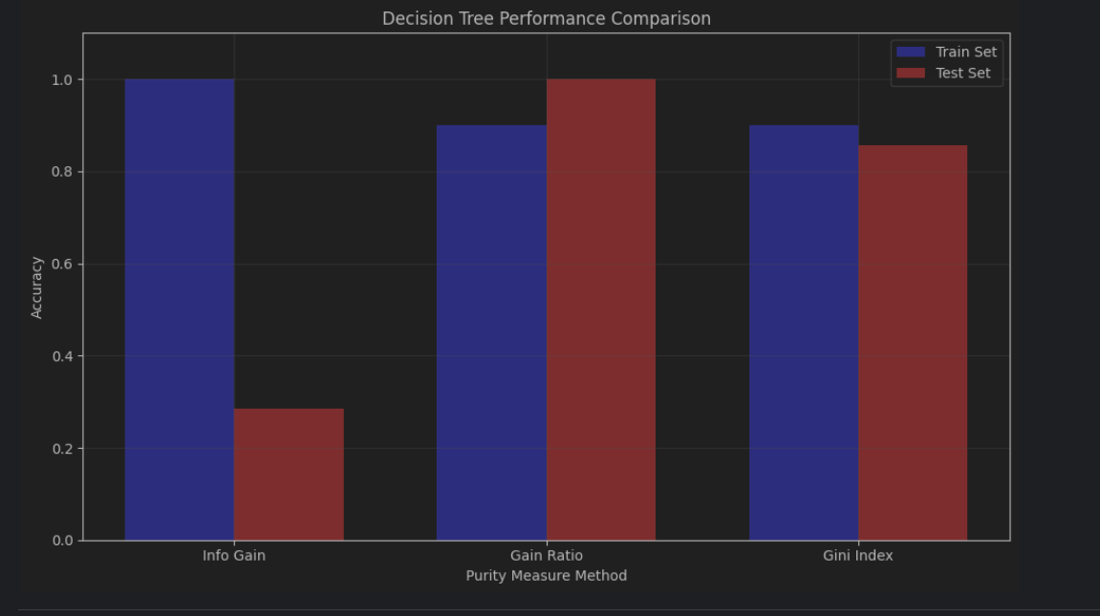
编号 色泽 根蒂 敲声 纹理 脐部 触感 好瓜
0 1 青绿 蜷缩 浊响 清晰 凹陷 硬滑 是
1 2 乌黑 蜷缩 沉闷 清晰 凹陷 硬滑 是
2 3 乌黑 蜷缩 浊响 清晰 凹陷 硬滑 是
3 6 青绿 稍蜷 浊响 清晰 稍凹 软粘 是
4 7 乌黑 稍蜷 浊响 稍糊 稍凹 软粘 是
5 10 青绿 硬挺 清脆 清晰 平坦 软粘 否
6 14 浅白 稍蜷 沉闷 稍糊 凹陷 硬滑 否
7 15 乌黑 稍蜷 浊响 清晰 稍凹 软粘 否
8 16 浅白 蜷缩 浊响 模糊 平坦 硬滑 否
9 17 青绿 蜷缩 沉闷 稍糊 稍凹 硬滑 否

Test Set:
编号 色泽 根蒂 敲声 纹理 脐部 触感 好瓜
0 4 青绿 蜷缩 沉闷 清晰 凹陷 硬滑 是
1 5 浅白 蜷缩 浊响 清晰 凹陷 硬滑 是
2 8 乌黑 稍蜷 浊响 清晰 稍凹 硬滑 是
3 9 乌黑 稍蜷 沉闷 稍糊 稍凹 硬滑 否
4 11 浅白 硬挺 清脆 模糊 平坦 硬滑 否
5 12 浅白 蜷缩 浊响 模糊 平坦 软粘 否
6 13 青绿 稍蜷 浊响 稍糊 凹陷 硬滑 否

1. Decision Tree using Information Gain:
Node(feature=色泽)
'乌黑': Node(feature=脐部)
'稍凹': Node(feature=纹理)
'稍糊': Leaf(class=是, samples=1)
'清晰': Leaf(class=否, samples=1)
'凹陷': Leaf(class=是, samples=2)
'青绿': Node(feature=敲声)
'沉闷': Leaf(class=否, samples=1)
'浊响': Leaf(class=是, samples=2)
'清脆': Leaf(class=否, samples=1)
'浅白': Leaf(class=否, samples=2)

Information Gain Test Accuracy: 0.2857
Test Predictions: ['否', '否', '否', '是', '否', '否', '是']
True Labels: ['是', '是', '是', '否', '否', '否', '否']

2. Decision Tree using Gain Ratio:
Node(feature=脐部)
'稍凹': Node(feature=敲声)
'沉闷': Leaf(class=否, samples=1)
'浊响': Node(feature=色泽)
'乌黑': Leaf(class=是, samples=2)
'青绿': Leaf(class=是, samples=1)
'平坦': Leaf(class=否, samples=2)
'凹陷': Node(feature=根蒂)
'稍蜷': Leaf(class=否, samples=1)
'蜷缩': Leaf(class=是, samples=3)

Gain Ratio Test Accuracy: 1.0000
Test Predictions: ['是', '是', '是', '否', '否', '否', '否']
True Labels: ['是', '是', '是', '否', '否', '否', '否']

3. Decision Tree using Gini Index:
Node(feature=脐部)
'稍凹': Node(feature=触感)
'软粘': Node(feature=色泽)
'乌黑': Leaf(class=是, samples=2)
'青绿': Leaf(class=是, samples=1)
'硬滑': Leaf(class=否, samples=1)
'平坦': Leaf(class=否, samples=2)
'凹陷': Node(feature=纹理)
'稍糊': Leaf(class=否, samples=1)
'清晰': Leaf(class=是, samples=3)

Gini Index Test Accuracy: 0.8571
Test Predictions: ['是', '是', '否', '否', '否', '否', '否']
True Labels: ['是', '是', '是', '否', '否', '否', '否']

Comparison of Three Purity Measures:
Information Gain Accuracy: 0.2857
Gain Ratio Accuracy: 1.0000
Gini Index Accuracy: 0.8571

Training Set Accuracy:
Information Gain: 1.0000
Gain Ratio: 0.9000
Gini Index: 0.9000

